<https://github.com/roxanazachman01/FLCD>

Documentation:

**Statement:**

**Implement a parser algorithm**

1. One of the following parsing methods will be chosen (assigned by teaching staff):

1.a. recursive descendent

    1.b. ll(1)

    1.c. lr(0)

2. The representation of the parsing tree (output) will be (decided by the team):

    2.a. productions string (max grade = 8.5)

    2.b. derivations string (max grade = 9)

    2.c. table (using father and sibling relation) (max grade = 10)

**Deliverables**:

1. Class Grammar (required operations: read a grammar from file, print set of non-terminals, set of terminals, set of productions, productions for a given nonterminal, CFG check)
2. Input files: g1.txt (simple grammar from course/seminar), g2.txt (grammar of the minilanguage - syntax rules from [Lab 1b](https://moodle.cs.ubbcluj.ro/mod/assign/view.php?id=2562))

**Implementation**:

The input file is read in the constructor of the Grammar, then the loaded elements are validated. (throws exception if starting symbol is not a nonterminal or elements in productions are neither terminals or non-terminals).

The starting symbol is stored as a Nonterminal type, which implements the interface TermOrNonTerm. The set of non-terminals are stored as Nonterminal type and terminals as Terminal type. The list of production is stored as an array list of type Production, which is a class that contains a list of TermOrNonTerm as left hand-side and right hand-side. The reason for using the interface is to be able to store both terminals and non-terminals in the same list, since they have the same behaviour. (methods for getting the value and checking whether it is a terminal or nonterminal).

The code checks whether the grammar is a cfg by checking the size of the left hand-side in the list of productions. If all productions have size 1, then it is a cfg.

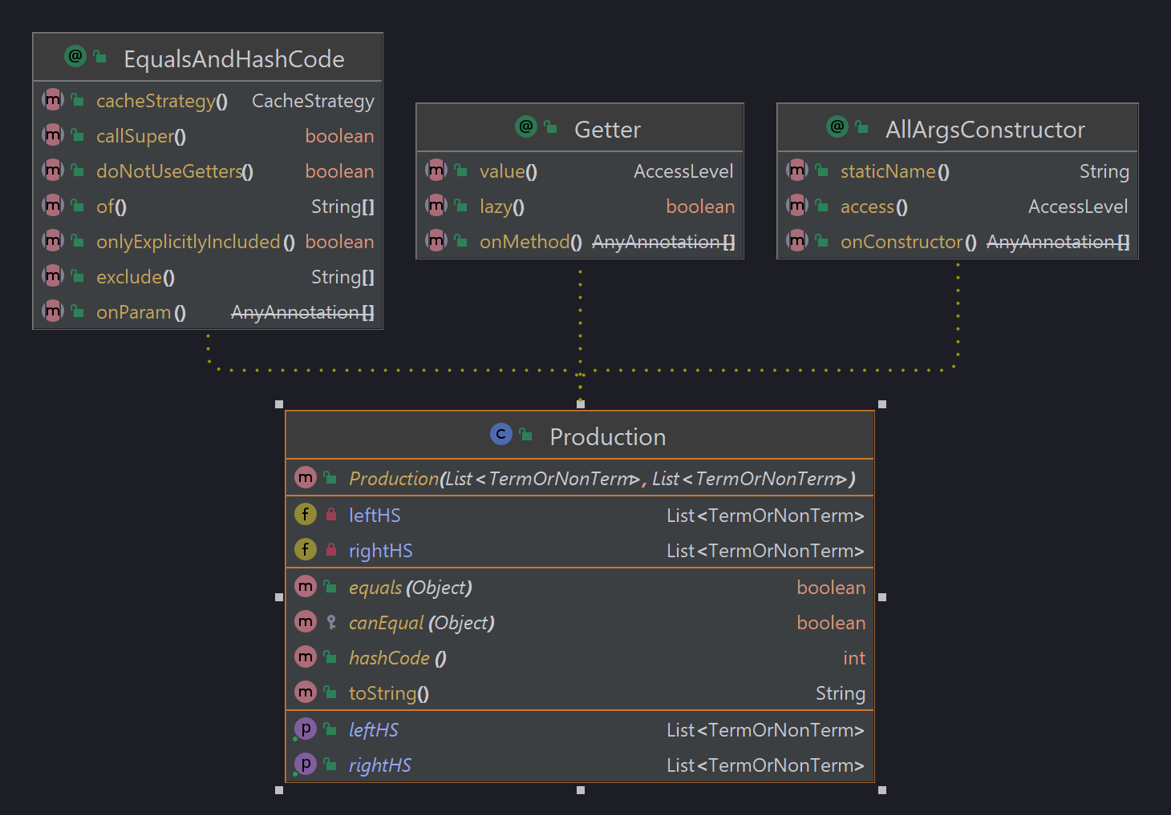

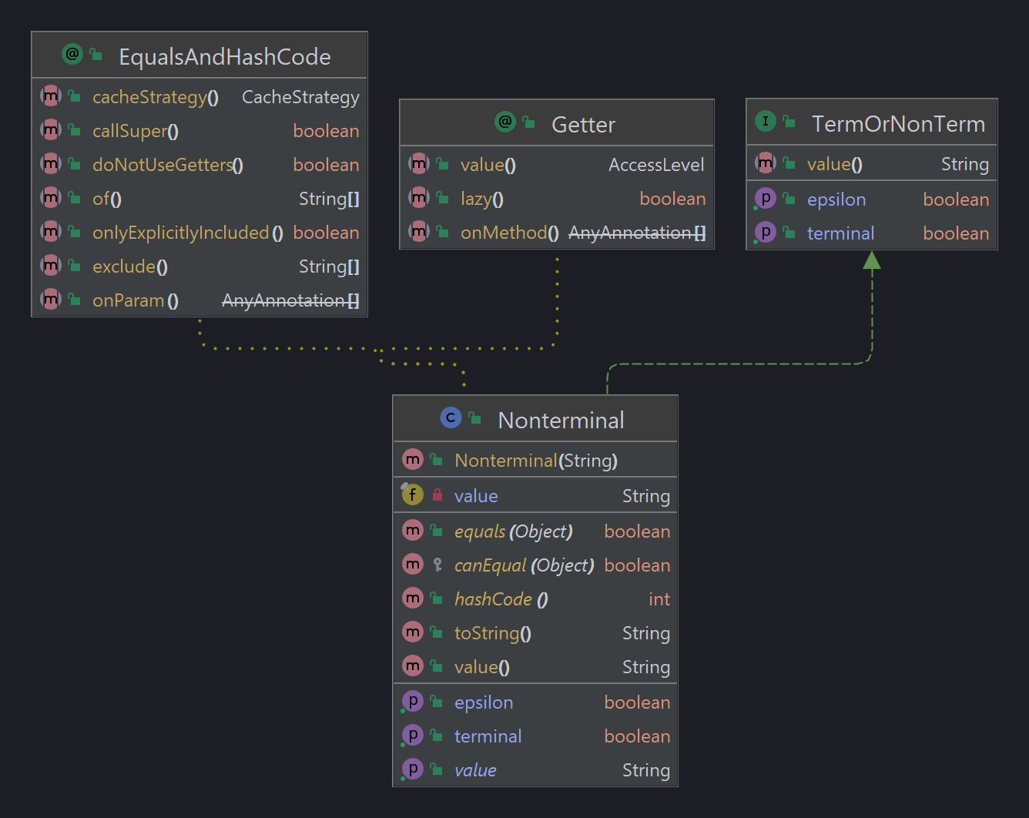

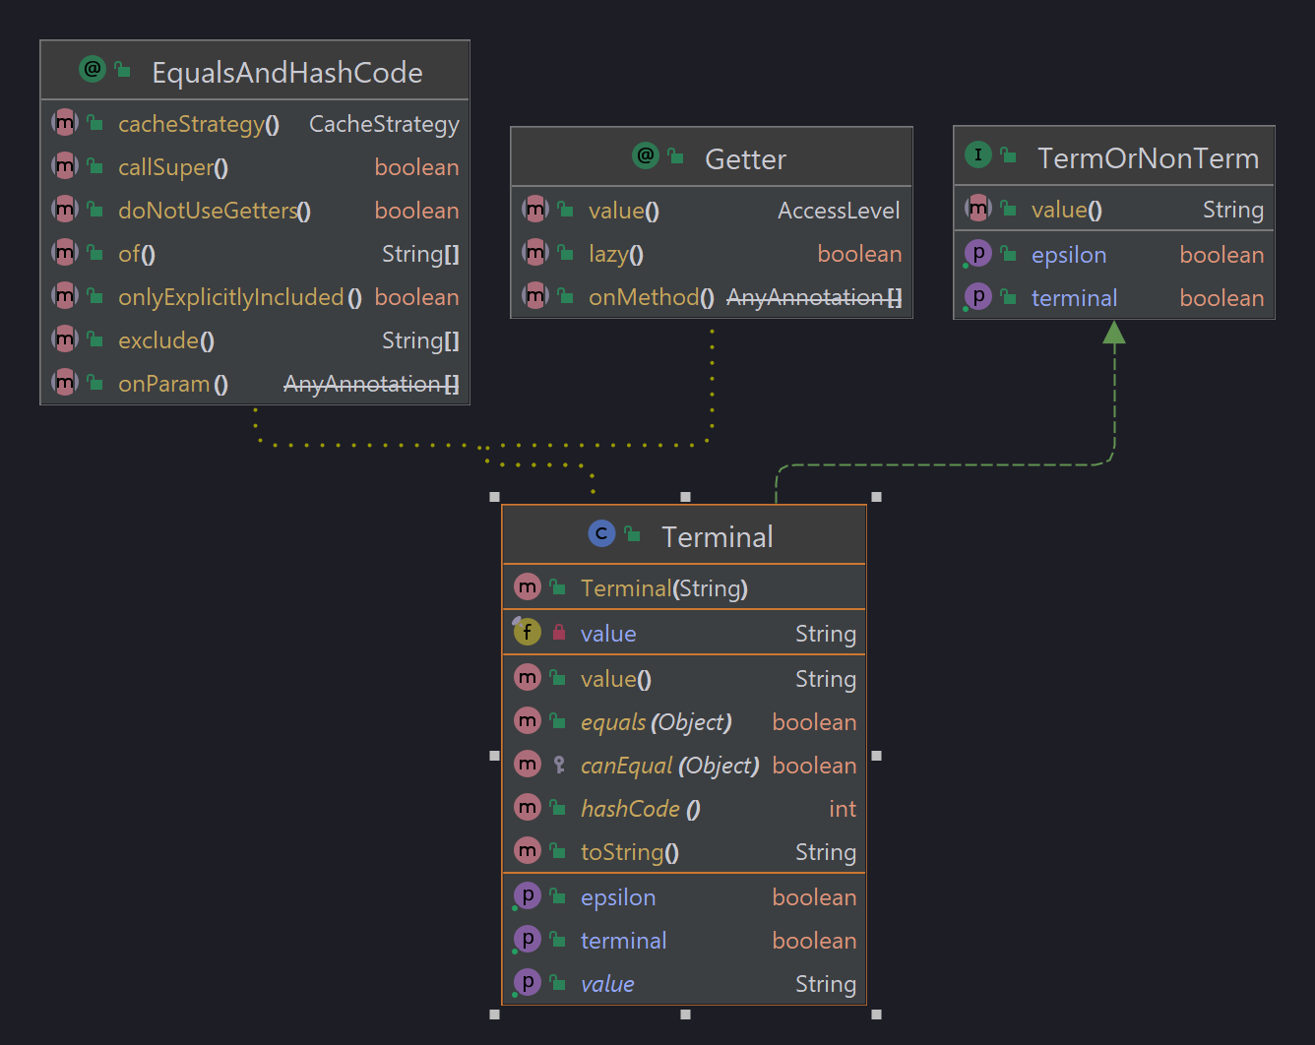

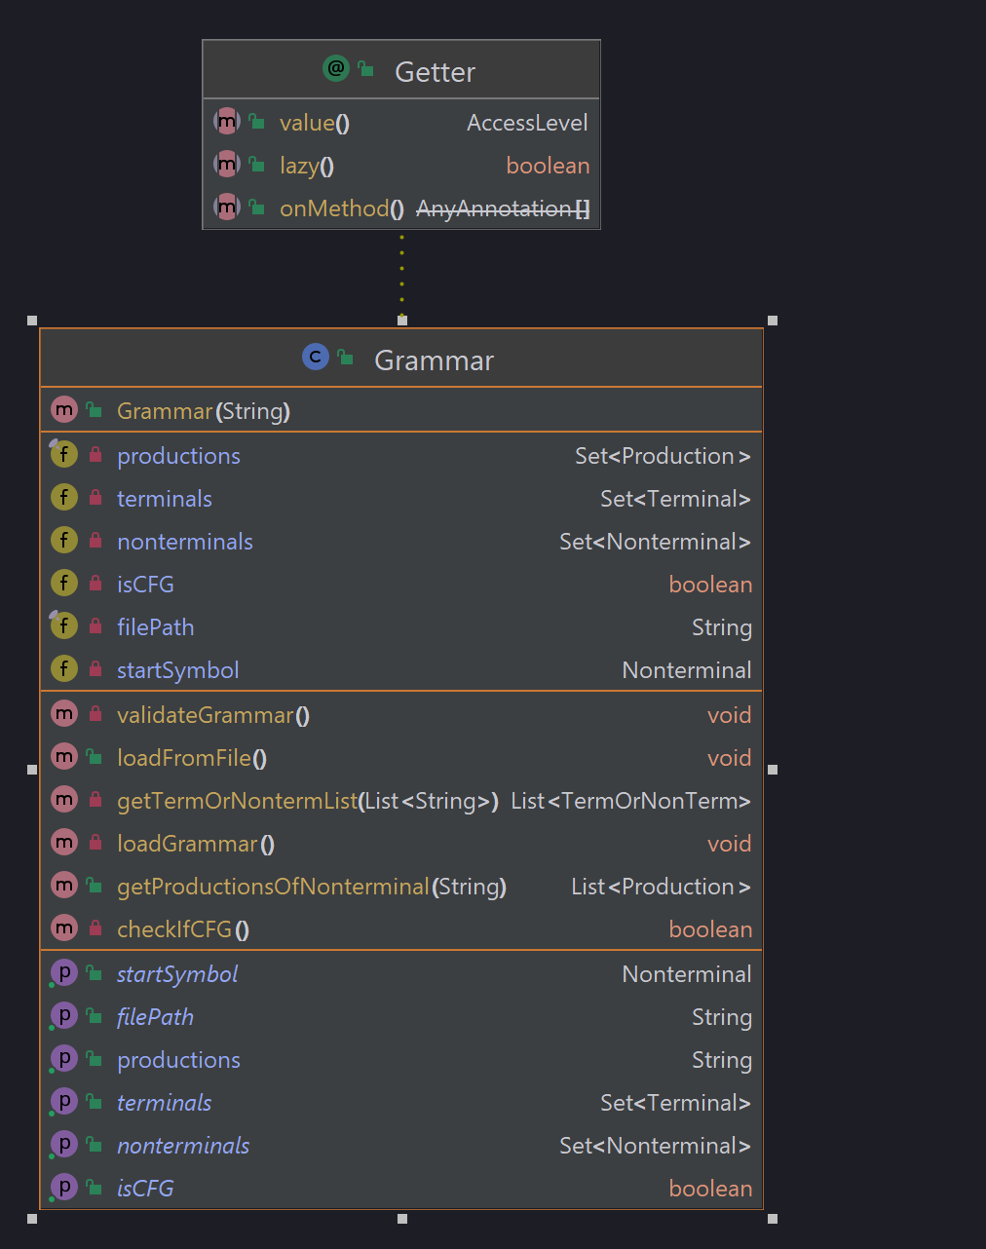

**Testing**: tests the grammar loads correctly the input file for the mini language

Input file:

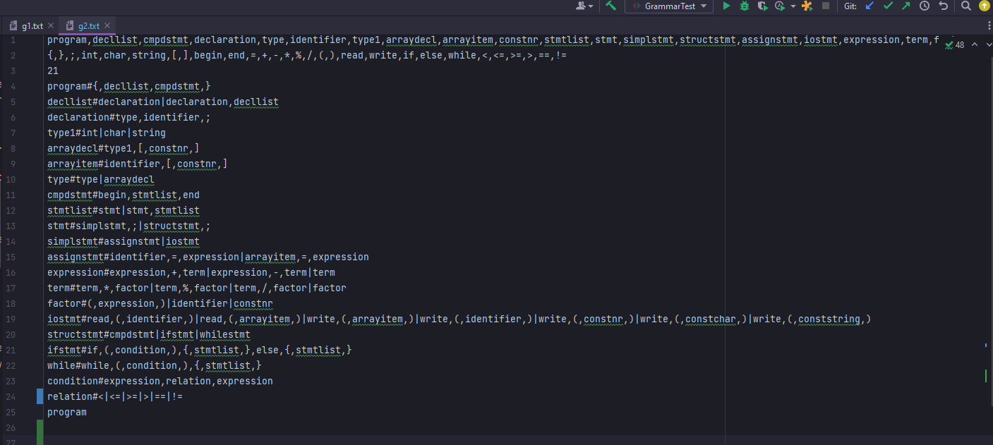

Tests:

